Professional Development

- Go to MYNC and click on the Staff Icon.
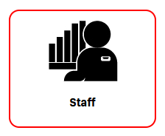
- Once you sign into Staff, to submit a professional development course, select the PROFESSIONAL DEVELOPMENT tab next to SHOW PROFESSIONAL DEVELOPMENT ACTIVITY.
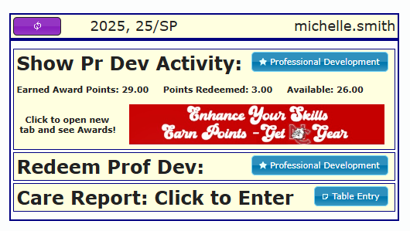
- When you open the Grid, you will see the Top line is Yellow – to enter a Professional Development course – double click on the yellow line and that will open up the window to enter your information.
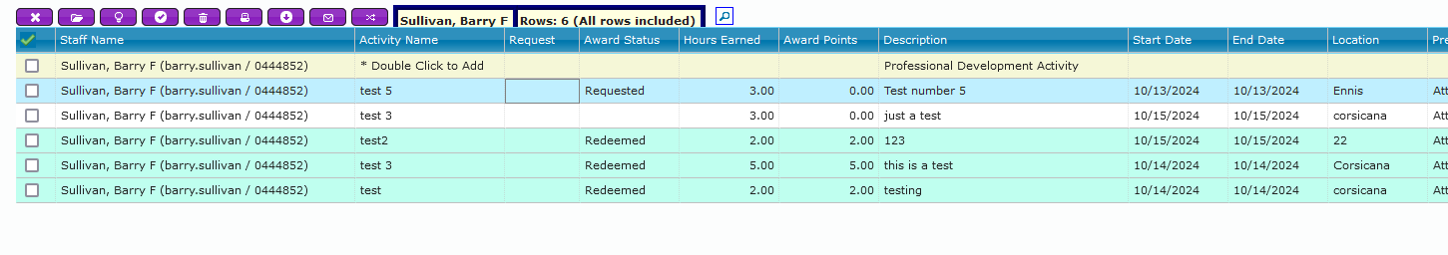
You will notice that the lines are color coded –
  - White indicates that you have entered the Professional Development hours.
  - Blue indicates you have requested to redeem those points for merchandise.
  - Green indicates that those points have been redeemed by HR for merchandise.

- Enter your data but do not select the for office use only boxes. Once you have completed your entry,
you will need to click the PURPLE CHECK BOX in the upper left corner. It will turn green to save your work.

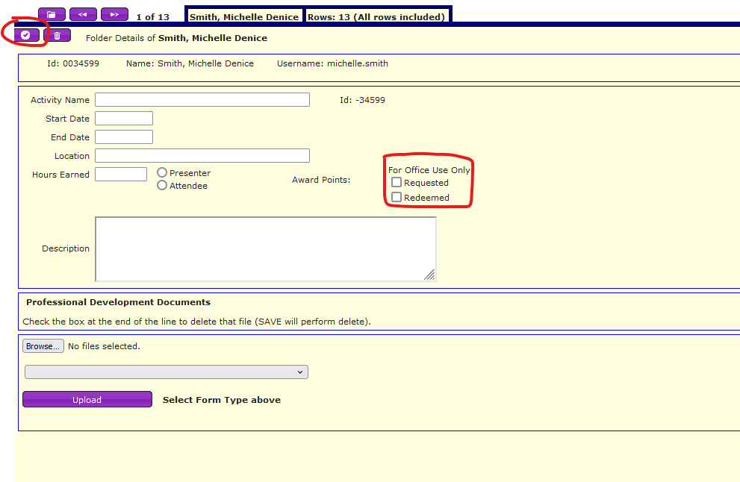

- Once you have submitted your hours, no further action is needed until you are ready to redeem points for merchandise. Once you are ready to do so, follow the additional instructions below.

- To view items available for purchase with points select the red EARN POINTS – GET GEAR tab.

- To Request that your points be redeemed for merchandise, under the column REQUEST, click the
drop down and select Y for yes.
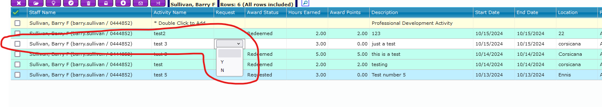
- Once you have selected all the points you would like to redeem, email Michelle.Smith@NavarroCollege.edu
and let us know which item you would like to purchase with your points. You can redeem as many points as
you would like or you can save them up for larger items.

